*Bud Light’s Advertisement Disaster – Using Data Science Techniques to Determine the Causal Impact of Bud Light’s Public Relations Nightmare*

In this case study, I will review the rapidly developing current story of Bud Light’s most recent “scandal”. In April of 2023, Bud Light ran an advertisement campaign featuring prominent transgender social media star Dylan Mulvaney. The campaign celebrated both March Madness & Mulvaney’s first year of womanhood. In fact, Bud Light promotional cans stemming from the advertisement campaign prominently featured Mulvaney’s image.

Obviously, this is a relatively sensitive subject in modern America. I will make no comment towards transgenderism; however, I will state the facts of the matter throughout this paper. Regardless, Bud Light’s core demographic mostly consists of conservative white men from middle America. Needless to say, Bud Light’s core demographic did not take kindly to the political gestures espoused in the advertisement campaign.

After the campaign, conservative media and other social media figures quickly voiced their displeasure, and many began to publicly call for a nationwide boycott of Bud Light as a whole. In fact, a viral video of Kid Rock did the rounds on the internet, showing the music star shooting cans of Bud Light beer with various weapons that displayed Mulvaney’s face. Similarly, other music stars like Travis Tritt publicly banned the beverage from his music tour in spite of a rather lucrative sponsorship deal with Bud Light’s parent company, Anheuser-Busch. And, liquor stores and bars across middle-America are no longer purchasing Anheuser-Busch products to stock their shelves. In aggregate, there are many prominent conservative figures in the media and in the political sphere further fanning the flames.

Naturally, a public relations disaster of this magnitude had significant impact of Anheuser-Busch stock price and overall reputation. But, to what extent? In this case study, I aim to answer that question. I will analyze the impact of this advertisement disaster by developing a Bayesian structural time-series model. Moreover, I will rely on historical stock price data primarily to develop my mathematical model.

The first thing I want to do is to define the dates of importance. To do so, I will define a start date, end data, and, most importantly, a treatment date. In this instance, the treatment date can be considered as April 2023 – exactly when the advertisement campaign launched.

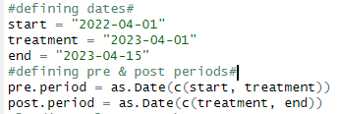

The start date was April 2022, giving my analysis a time horizon of approximately one year. As aforementioned, the treatment date alludes to when the Mulvaney campaign was published, and the end date is defined as April 15, 2023. At the time of my analysis, this is the most recent day I have data on.

Next, I want to load the relevant packages necessary for my analysis into R to perform my analysis.

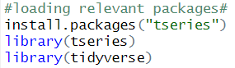

Now, I will be retrieving historical stock price data pertaining to Anheuser-Busch.

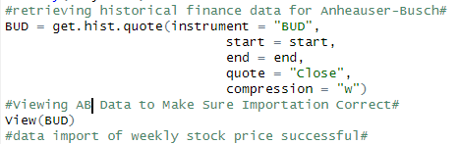

From the table retrieved, I can clearly see weekly stock price variation in relation to Anheuser-Busch.

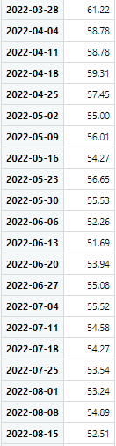

Now, this data is great to have; however, I need more data to conform to the assumptions of my Bayesian structural time-series model. In particular, I need to add some control groups necessary for analysis. As a whole, stock markets are complex interconnected systems where various local factors can cause global changes in the behavior of the entire market. In particular, I want these control groups to be correlated with the stock price of Anheuser -Busch to represent contagion. In relation, contagion in financial markets essentially implies the propagation of impact between different components of the market.

Ultimately, I decide on using four control groups, consisting of technology, entertainment, pharmaceutical, and manufacturing industries respectively. I determine that I will use Apple, Disney, Novartis, and Carlsberg as representative companies. I will then combine the stock price data of Anheuser-Busch, Apple, Disney, Novartis, and Carlsberg into a single data frame.

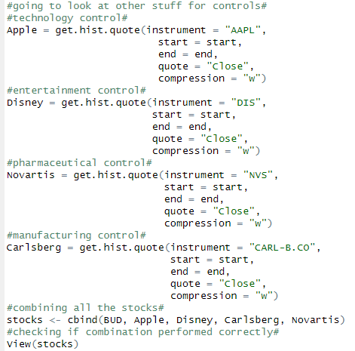

Upon viewing the newly created data frame titled stocks, I can see the weekly stock price variation of all five companies in a tabular format.

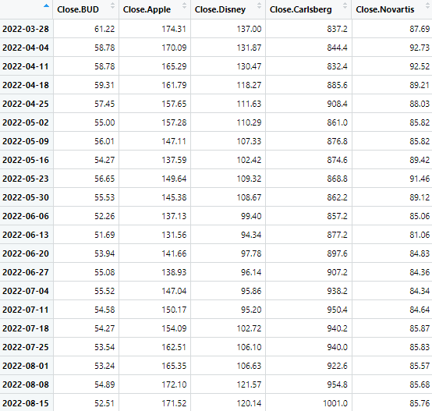

Now that I have combined all the data, I will conduct some correlation checks to make sure the control groups are “good enough” to be included in my model. As aforementioned, ideally, I would want to see some correlation. The stock price indexes that are not correlated are not useful for the purposes of my analysis & should be discarded.

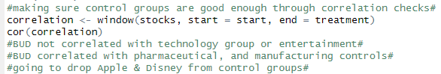

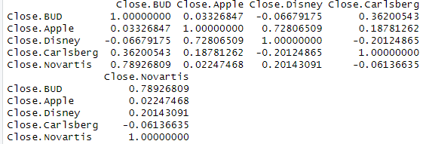

As you can see from the above summary statistics table, Anheuser-Busch stock price is not correlated with Apple stock price or Disney stock price. So, I endeavor to drop the technology and entertainment controls from my model moving forwards. Conversely, Anheuser-Busch is correlated with my pharmaceutical and manufacturing controls respectively, so Novartis and Carlsberg stay in my model moving forwards.

To develop my model, I will now combine the necessary data for analysis into a new data frame titled final stocks.



I can then view my newly created data frame, representing weekly stock price variation in Anheuser-Busch, Carlsberg, and Novartis.

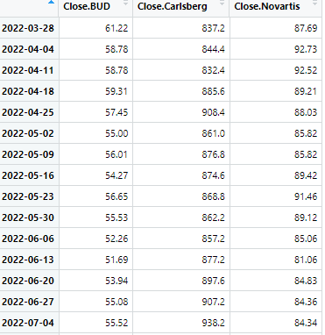

Now that I have taken all the necessary measures to prepare my model, I will now go about actually performing the causal impact analysis. I will install packages necessary for analysis, create a new data frame titled impact, and I will produce a visual to help clearly and concisely tell the underlying story of the data.

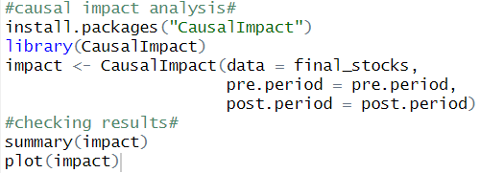

From the results of my model, there are a few things I want to highlight in particular.

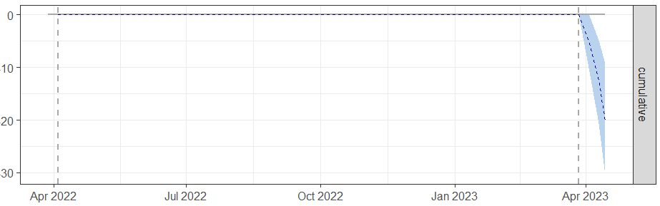

First, I want to highlight the visualization above. Foremost, you can clearly identify the vertical dotted line occurring around April 2023. This vertical dotted line represents the treatment period, which refers to exactly when the transgender advertisement campaign was actually published. Basically, this line represents the origin of controversy.

Second, the horizontal dotted line at the top of the visualization remains at zero until the treatment period takes place. You can think of this horizontal line as normalized stock price fluctuation of Anheuser-Busch UNTIL the advertisement effects comes into effect.

Lastly, notice the behavior of the line after the treatment, or advertisement campaign, is launched. There is a rapid negative decline. Similarly, notice the y-axis. The y-axis essentially represents chance in percentage terms. So, post-treatment, Anheuser-Busch stock price rapidly declined by over 20 percentage points in a couple weeks.

To put it simply, the visualization tells the story of the Bud Light’s public relations nightmare stemming from their transgender advertisement campaign. The “scandal’s” effect on the market capitalization of Anheuser-Busch, Bud Light’s parent company, was practically immediate. As you would expect, the outcry of Bud Light’s audience and the subsequent national boycott stemming from the advertisement contributed to a rapid negative decline of Anheuser-Busch’s stock price.

Given that this is a recent event, it remains to be seen if Anheuser-Busch stock will ever recover. In fact, I intuitively suspect it will continue a downward trend for quite some time. I wanted to remind the potential audience reading this that this experiment was conducted April 15, 2023. This is only a couple weeks after the advertisement in question was published. Given a longer time horizon, it is very possible that the stock price could continue to drop, delving into the 30 percentage points and beyond territory.

Finally, I would like to bring to your attention the summary statistics of my model.

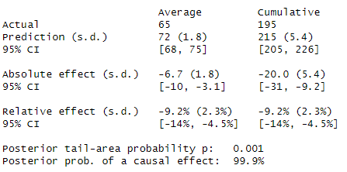

You likely do not need to understand the majority of this table. However, I wanted to highlight one thing in particular: the posterior probability of a causal effect is 99.9%. Essentially, in statistical terms, I can conclude that I am 99.9% certain that Anheuser-Busch’s rapid stock price decline was directly *caused* from the treatment, which represents the origin of the transgender advertisement campaign. In other words, we are practically certain that the stock price fluctuation observed is directly caused by the event of Bud Light’s public relations nightmare stemming from the appearance of transgender Dylan Mulvaney in their recent advertisement campaign.

At the time of writing this case study, Anheuser-Busch has been reported to lose over $5 billion in market cap in the last couple weeks alone.

**For more context:** (I will provide two different perspectives since the topic is inherently political)

**Left-Wing perspective:** <https://www.vox.com/money/2023/4/12/23680135/bud-light-boycott-dylan-mulvaney-travis-tritt-trans>

**Right-Wing perspective:** <https://www.foxbusiness.com/lifestyle/anheuser-busch-breaks-silence-bud-lights-dylan-mulvaney-controversy>